Webserver and App server
- Installation of Apache or httpd
Yum install httpd
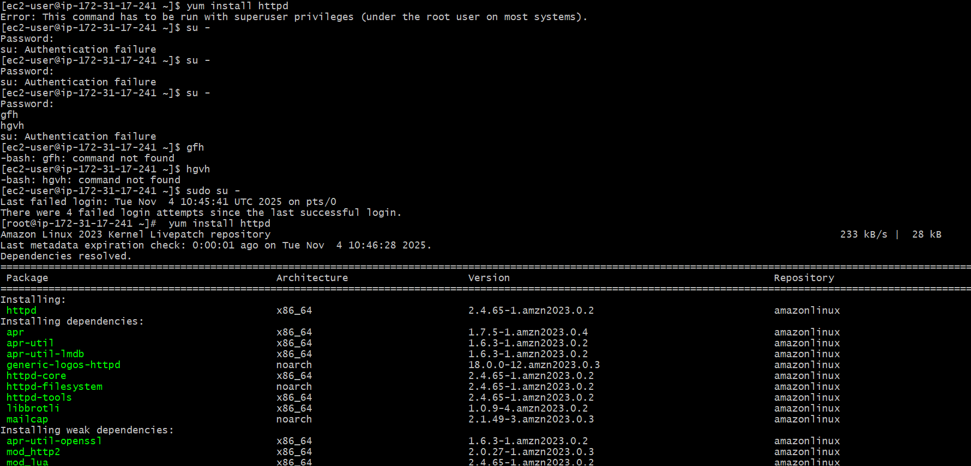
Using grep and with 80 port number
netstat -na | grep 80
tp :80

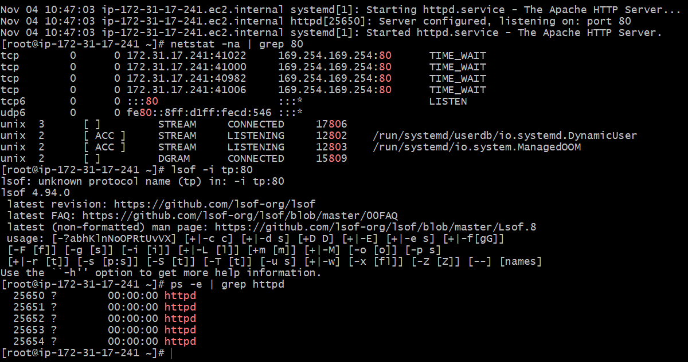
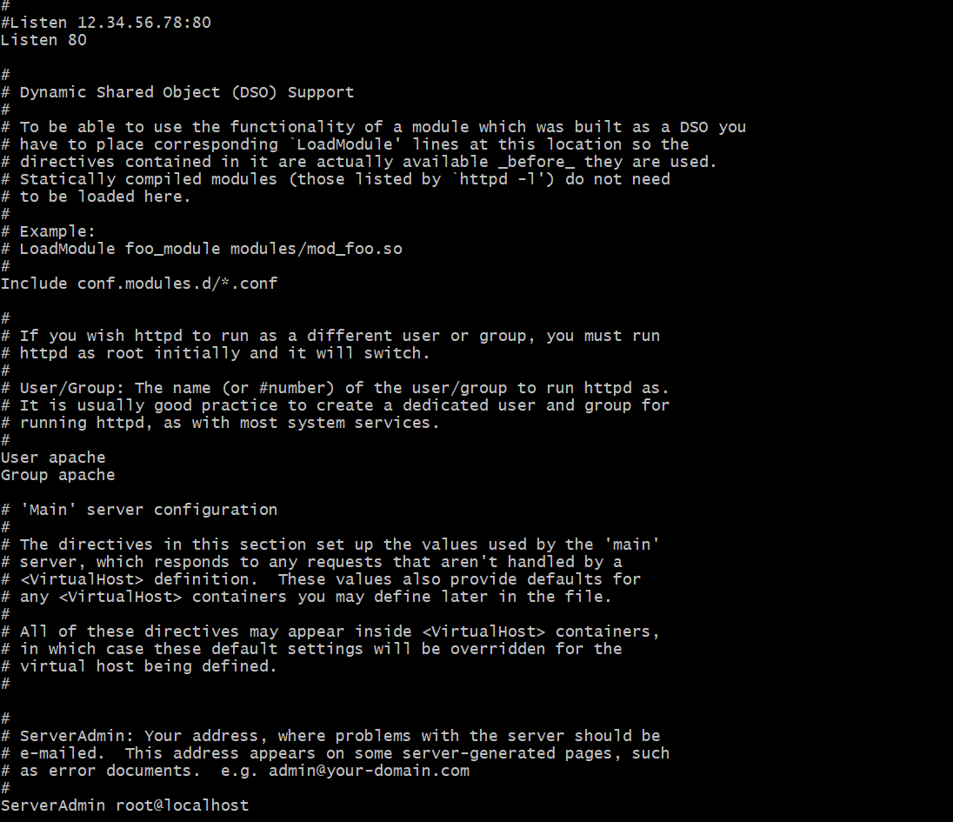

From port number 80 to 82
To change configuration
find / -name httpd.conf
cat and copy the filename and paste it
cd /etc/httpd/contro;c
cat /etc/httpd/conf/httpd.conf control
ls
httpd.conf u can see
mv httpd.conf httpd.conf.backup
ll
copy the content manually
to change the port number
vi httpd.conf
paste and edit to 80 to 82
save the file esc:wq!
Ll
Systemctl restart httpd
Systemctl status httpd
Now the port has been changed

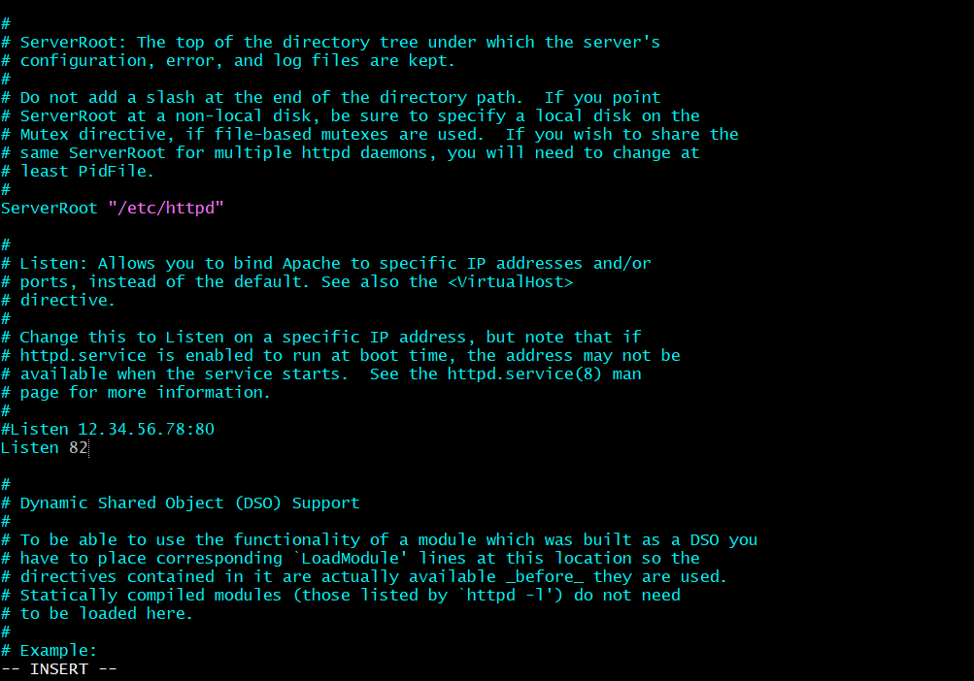
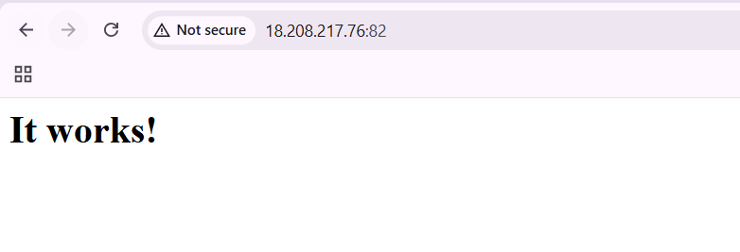
- To deploy a sample index.html on Apache
Cd /var/www/html
Ll
Touch index.html
;;
‘;;’
Vi index.html
<h1> change the name
Finally executed
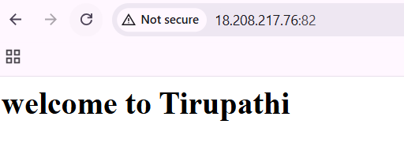
- Install of nginx and run nginx on port number 81
Yum install nginx
If it’s not getting
Try sudo amazon-linux-extras install nginx1
Systemctl start nginx
Systemctl status nginx
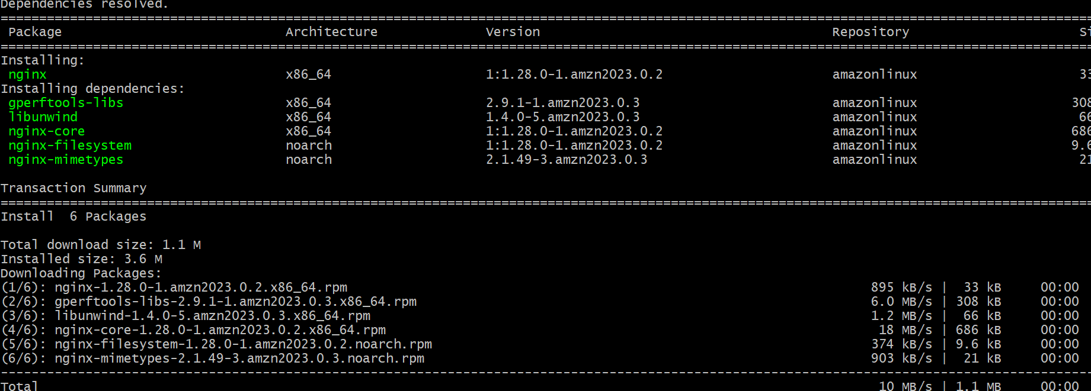
To start the nginx to port number
First stop wat is running before service
Systemctl stop httpd
Now u can refresh

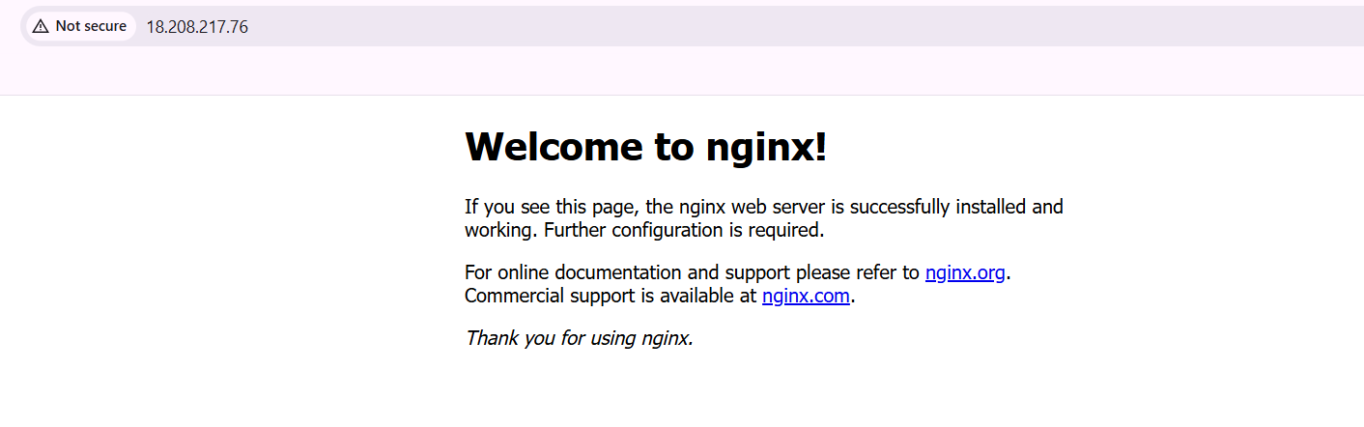
- Deploy a sample index.htmli file on nginx
By using
cd /usr/share/nginx/html/
ls
to create our own file name
use vi index.html
now you can edit the name from welcome to nginx to whatever you required name
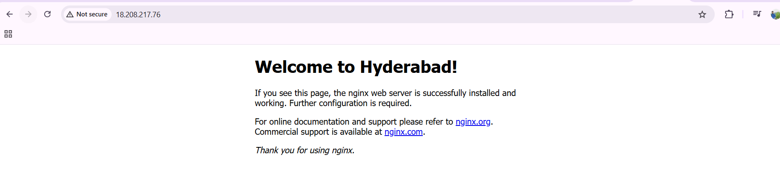
Nginx port number 80
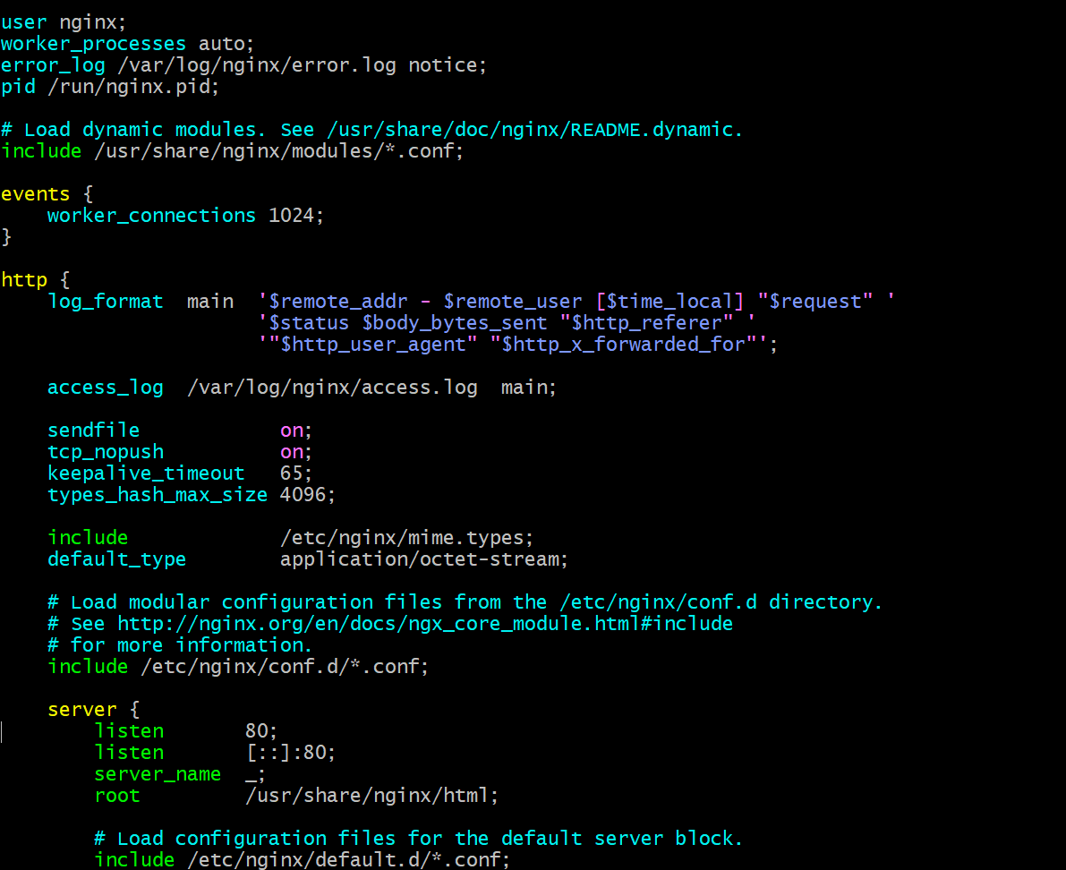
To change port number from 80 to 81
Cd /usr/share/nginx/html
Cat /etc/nginx/nginc.conf
Vi nginx.conf

We need to crate with vi and edit and save it
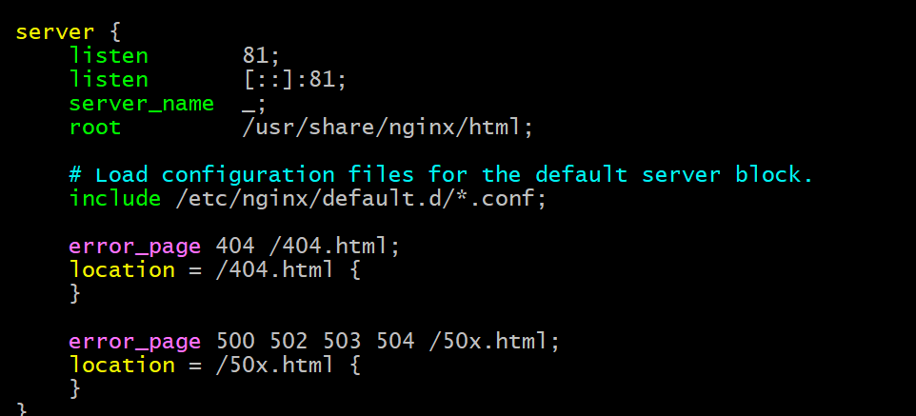
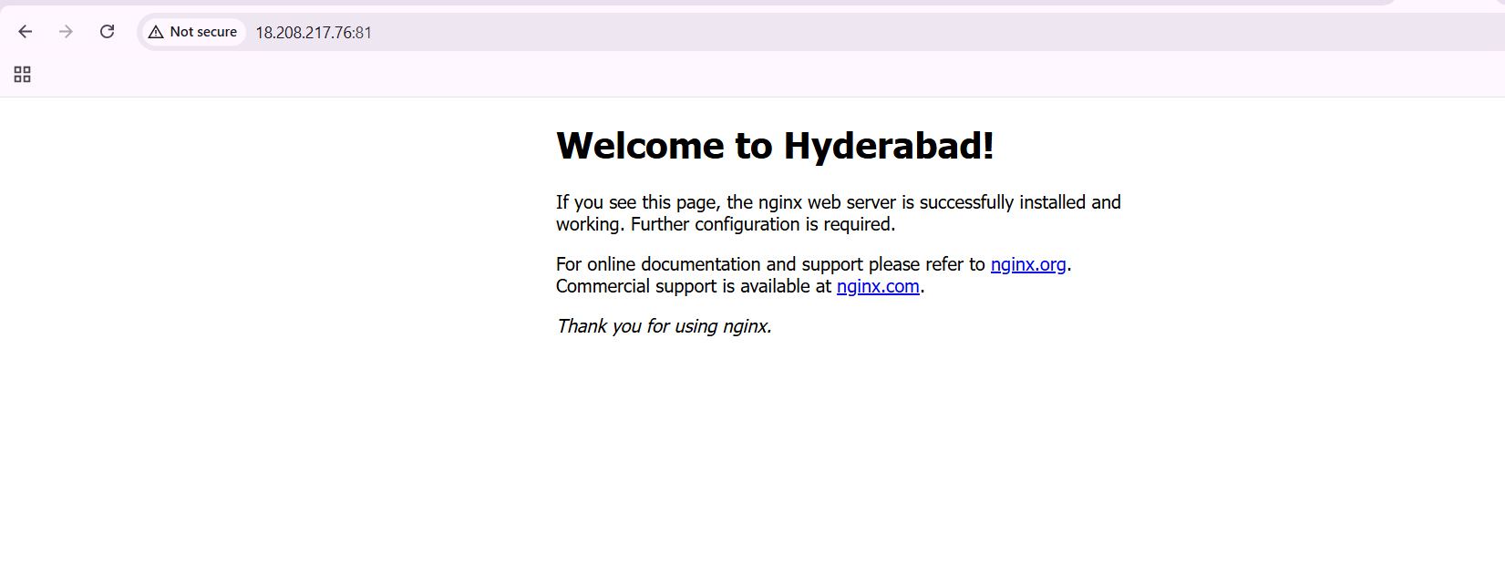
- Installation Apache tomcat installed and run with 8080 and changing port number 8080 to 8082
First we need to take from google Apache downloads
Select the tar link and copy link
Using cd /opt/
wget and paste the link
ls
we can see two links
if we go to cd apache…..
we can see different toots called bin conf lib temp webapps work
cd bin/
ls
./startup.sh
Tomcat executed
Note: make sure the java has been installed before only
To install yum install java
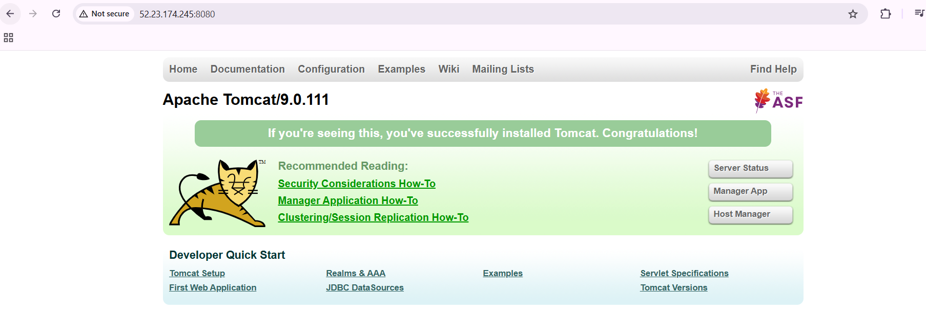
From 8080 to 8082
Cd bin/
Ls
cd..
cd conf/
ls
vi server.xml
we need to edit from 8080 to 8082
ls
again cd bin/
ls
frist we need to shutdown
./shutdown.sh
Then ./startup.sh
Finally refresh the web page
The port has been changed from 8080 to 8082

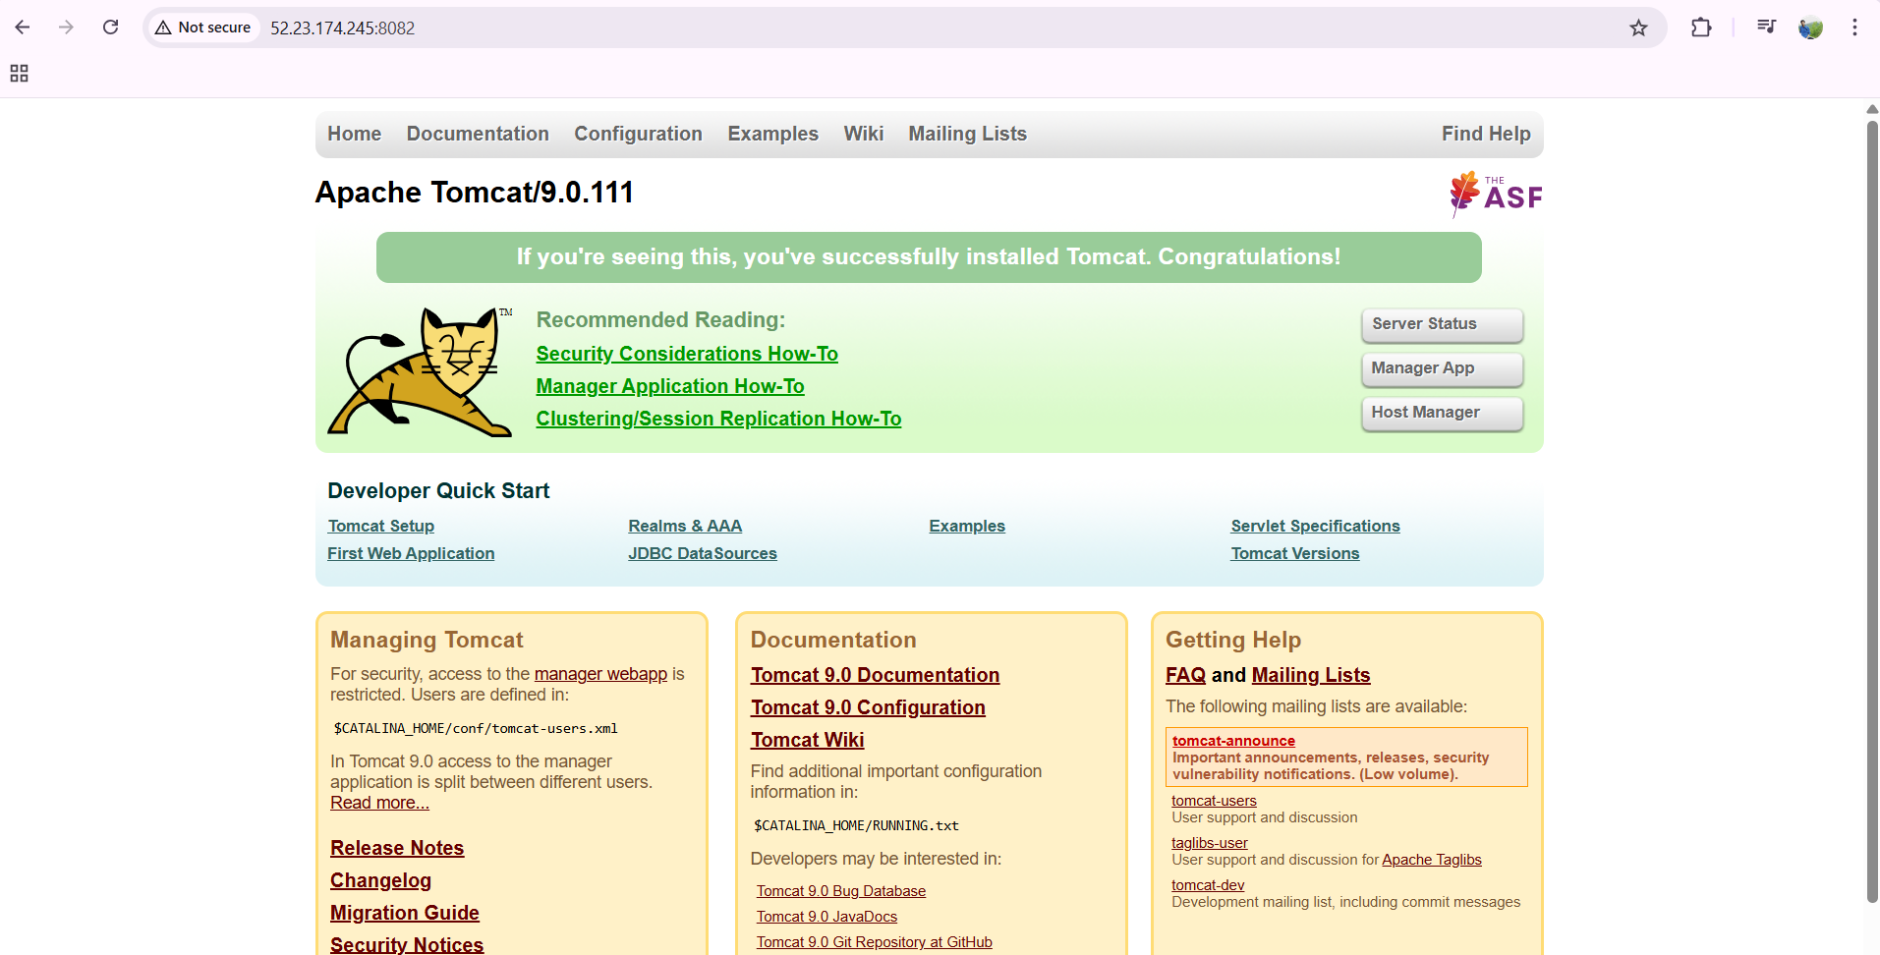
- To deploy one application in webapps
Cd webapps/
Ls
Go to google and type sample.war
Copy the link address
And
Wget paste it
ll
U can see one application called sample.war
ll
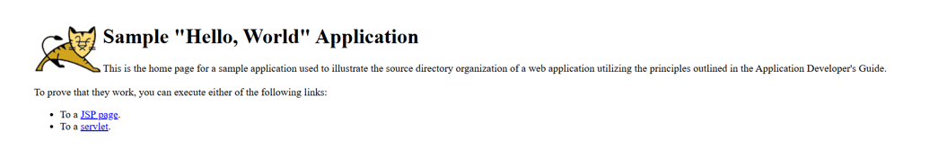
To create our own application
Cd sample
Ll
Vi index.html
Edit the name of application
And save it
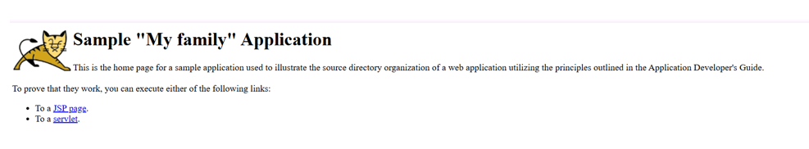
- Create a tomcat.service file on tomcat

cd /etc/systemd/system
touch tomcat.service
vi tomcat.service
[Unit]
Description=Apache Tomcat Server
After=network.target[Service]
Type=forkingEnvironment=JAVA_HOME=/usr/lib/jvm/java-17-amazon-corretto
Environment=CATALINA_HOME=/opt/apache-tomcat-9.0.111
Environment=CATALINA_BASE=/opt/apache-tomcat-9.0.111ExecStart=/opt/apache-tomcat-9.0.111/bin/startup.sh
ExecStop=/opt/apache-tomcat-9.0.111/bin/shutdown.shUser=root
Group=rootRestart=always[Install]
WantedBy=multi-user.target

save
systemctl daemon-reload
systemctl start tomcat
systemctl status tomcat

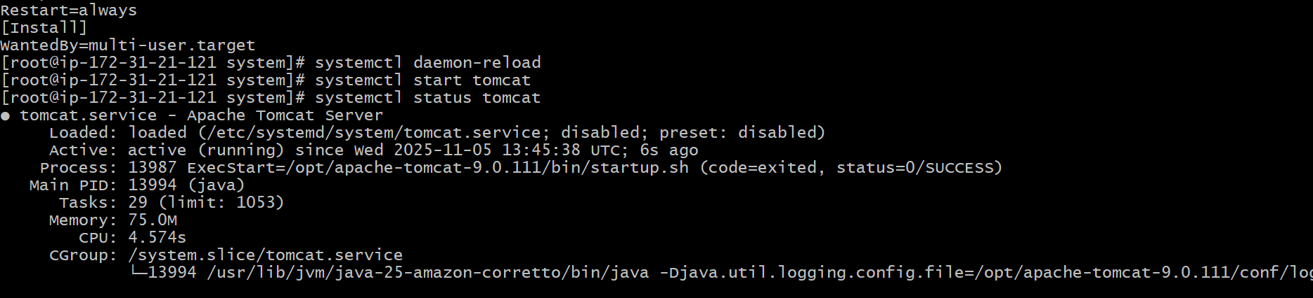
- Configure HA proxy server
To create 3 instances in aws
Server 1,server 2 and HA proxy server
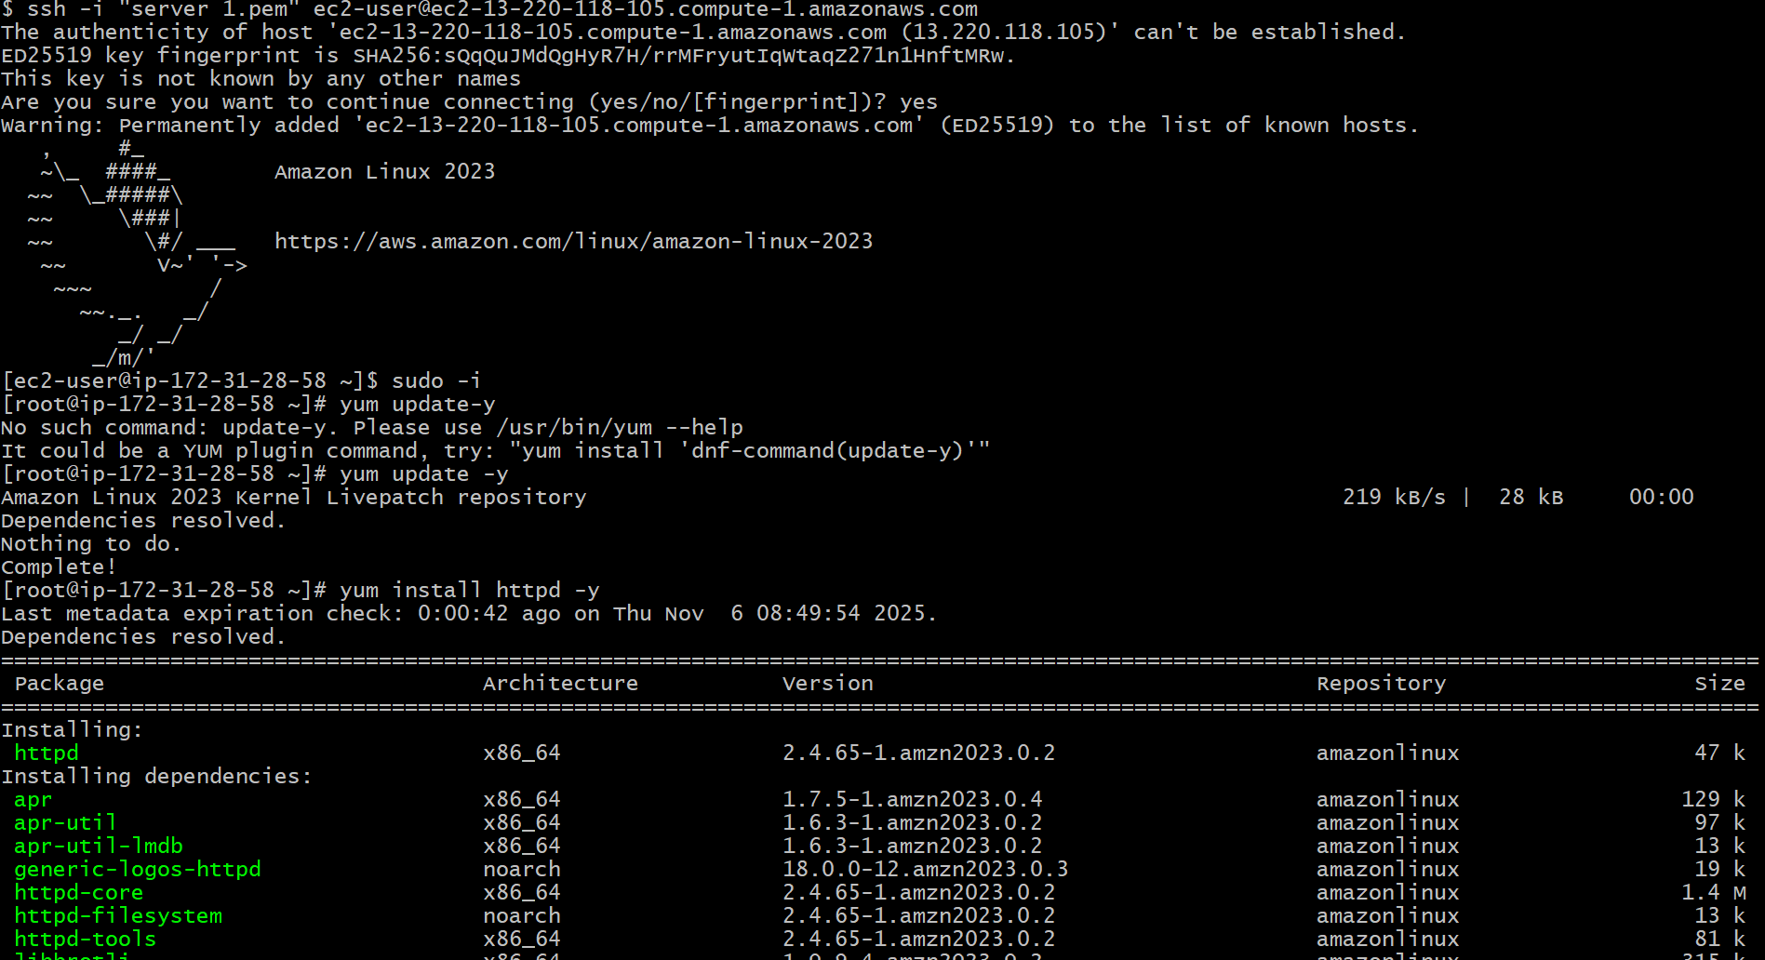
Tu run the server 1
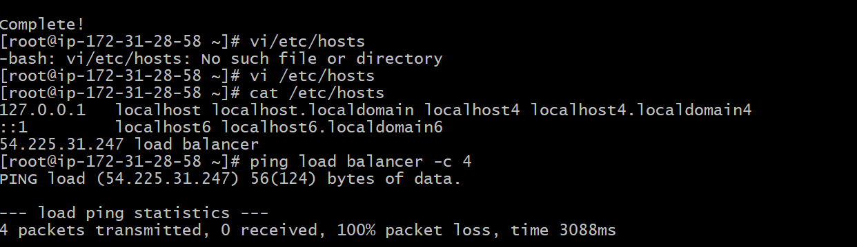
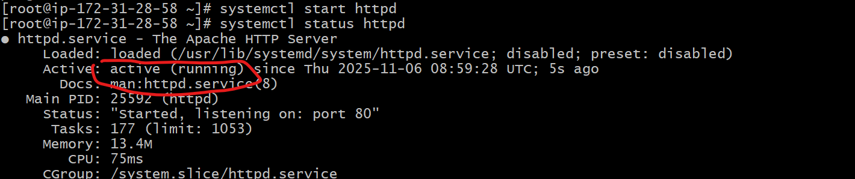
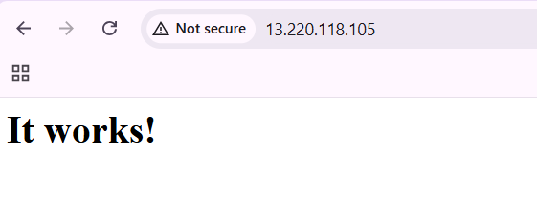

Server 2
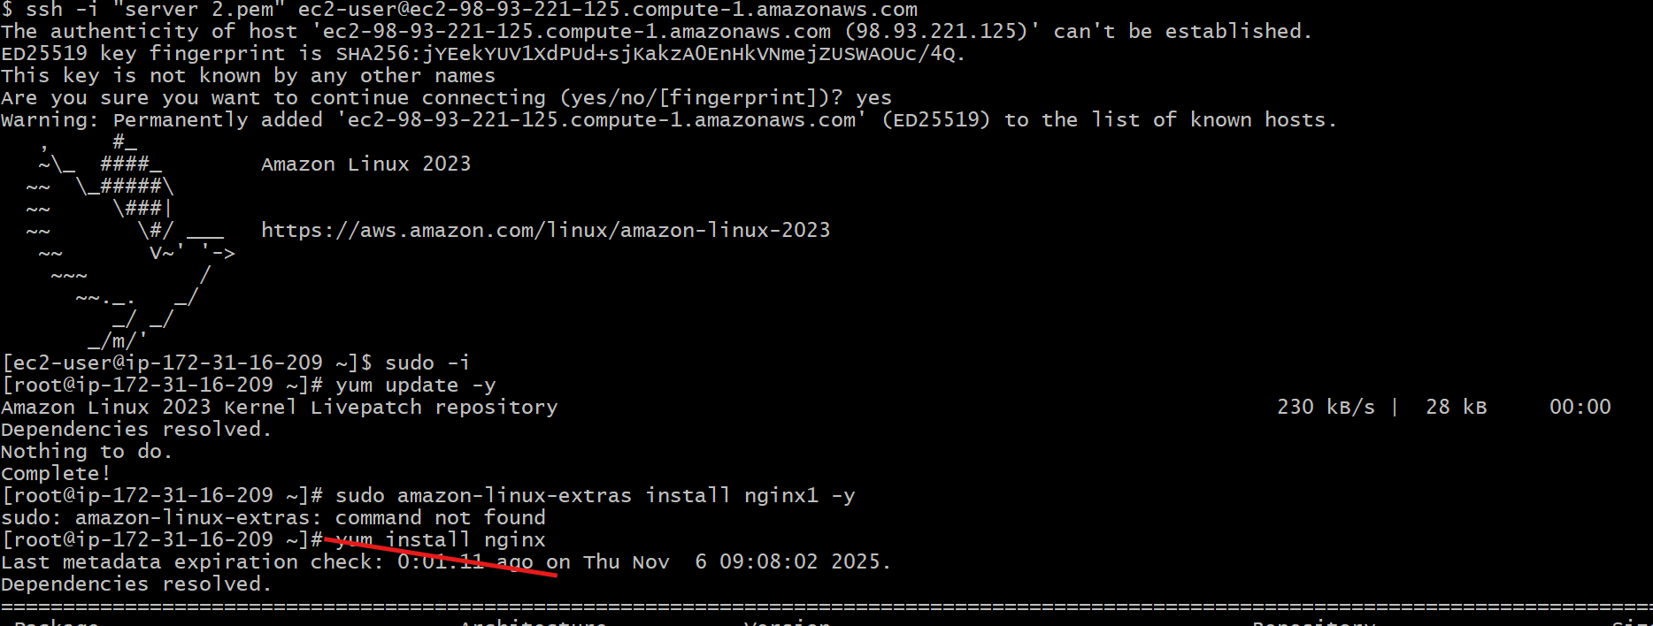
Tu run the server 2 and enter Ha PROXY address
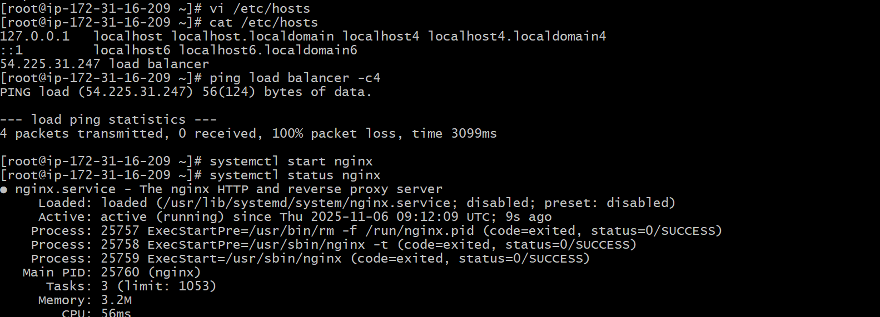
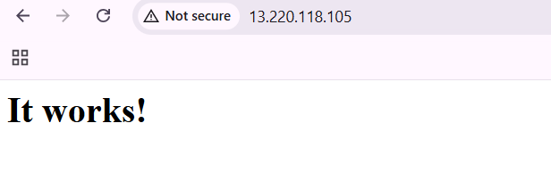
HA proxy server
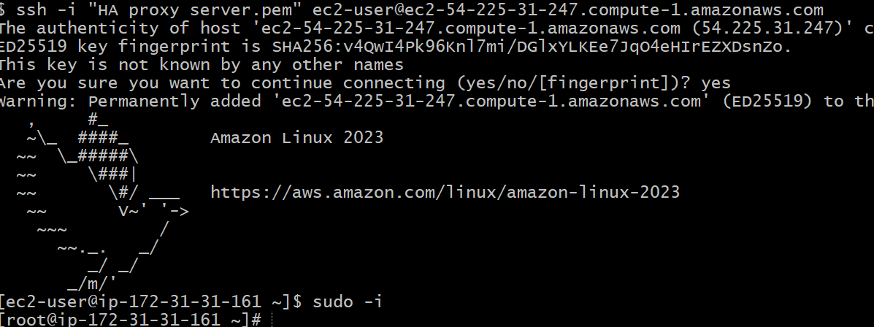
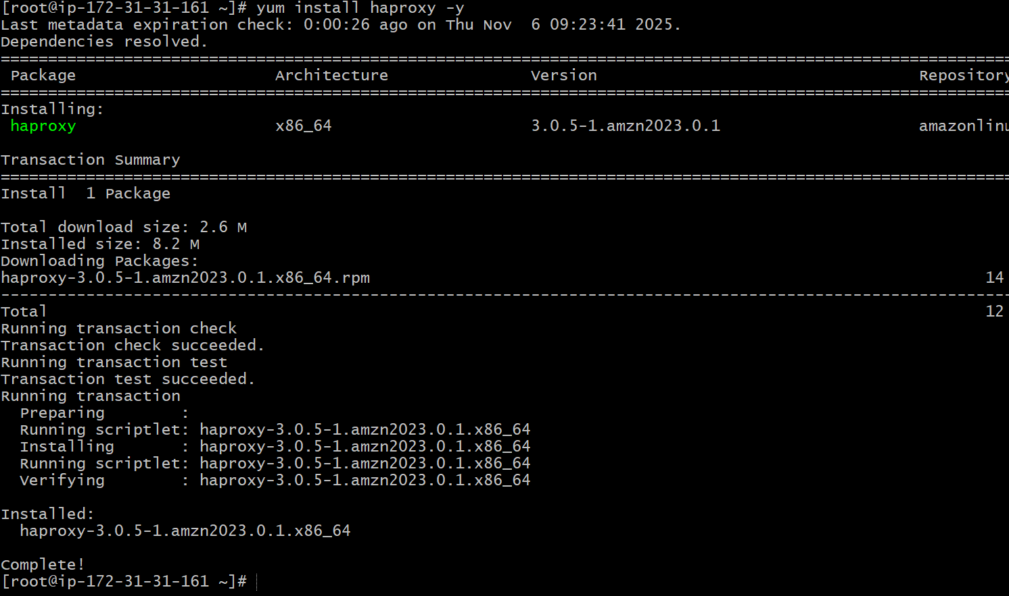
To run and add the servers 1 and 2 public id;s using vi
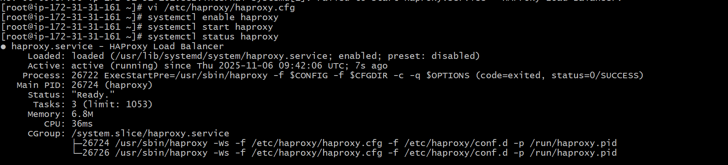
Finally it has been executed
